**Project Report Format**

**1. INTRODUCTION**

1.1 Project Overview

1.2 Purpose

**2. IDEATION PHASE**

2.1 Problem Statement

2.2 Empathy Map Canvas

2.3 Brainstorming

**3. REQUIREMENT ANALYSIS**

3.1 Customer Journey map

3.2 Solution Requirement

3.3 Data Flow Diagram

3.4 Technology Stack

**4. PROJECT DESIGN**

4.1 Problem Solution Fit

4.2 Proposed Solution

4.3 Solution Architecture

**5. PROJECT PLANNING & SCHEDULING**

5.1 Project Planning

**6. FUNCTIONAL AND PERFORMANCE TESTING**

6.1 Performance Testing

**7. RESULTS**

7.1 Output Screenshots

**8. ADVANTAGES & DISADVANTAGES**

**9. CONCLUSION**

**10. FUTURE SCOPE**

**11. APPENDIX**

Source Code(if any)

Dataset Link

GitHub & Project Demo Link

**1.INTRODUCTION**

**1.1 Project Overview:**

SB Works – A Seamless Freelancing and Collaboration Platform is a full-stack web application designed to simplify and digitize the process of connecting clients with skilled freelancers. In traditional freelancing environments, users often face challenges such as lack of transparency, communication gaps, difficulty in verifying freelancer credibility, delayed project tracking, and inefficient workflow management.

SB Works addresses these challenges by providing a centralized online platform where clients can post projects and freelancers can browse, bid, and deliver work efficiently in real time. The platform ensures a structured project lifecycle—from project posting and proposal submission to collaboration, final submission, and feedback.

Clients can explore freelancer profiles, review portfolios, compare proposals, and select the most suitable candidate based on skills, experience, and ratings. Freelancers can showcase their expertise, submit competitive bids, communicate directly with clients, and upload completed work securely within the system.

Admins oversee overall platform operations, monitor user activities, enforce platform policies, and ensure system integrity and security.

**1.2 Purpose:**

The primary purpose of the **SB Works** application is to enhance efficiency, transparency, and trust in the freelancing ecosystem through a digital platform.

The project focuses on reducing communication barriers, improving project tracking, and creating a secure collaboration space between clients and freelancers.

**Key Objectives of the System:**

* Providing an intuitive platform where clients can post projects and hire skilled freelancers.
* Allowing freelancers to discover opportunities and build professional portfolios.
* Enabling administrators to maintain platform governance and ensure secure operations.
* Delivering real-time updates, communication, and project status tracking.
* Creating a scalable and user-friendly freelancing system using modern full-stack technologies.

Overall, the project aims to bridge the gap between opportunity and talent by offering a reliable, structured, and efficient freelancing management solution that improves user experience and platform credibility.

**2.IDEATION PHASE**

**2.1 Problem Statement:**

In today’s freelancing industry, connecting clients with reliable freelancers can be challenging. Traditional methods often lack structured communication, transparent workflows, and proper project tracking. This results in misunderstandings, delayed deliveries, and reduced trust between users. Freelancers struggle to find genuine opportunities, while clients face difficulty identifying skilled professionals. Many systems do not provide secure and centralized collaboration. **SB Works** aims to solve these issues by offering a streamlined digital platform for efficient project management and secure freelance collaboration.

**Problem Statement -1 :**

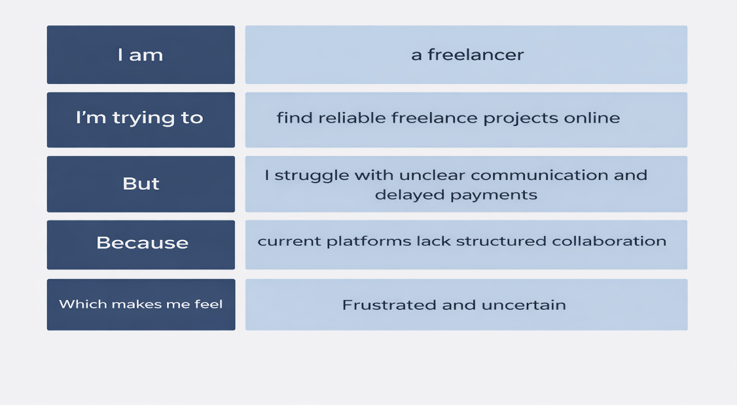

**Problem statement -2 :**

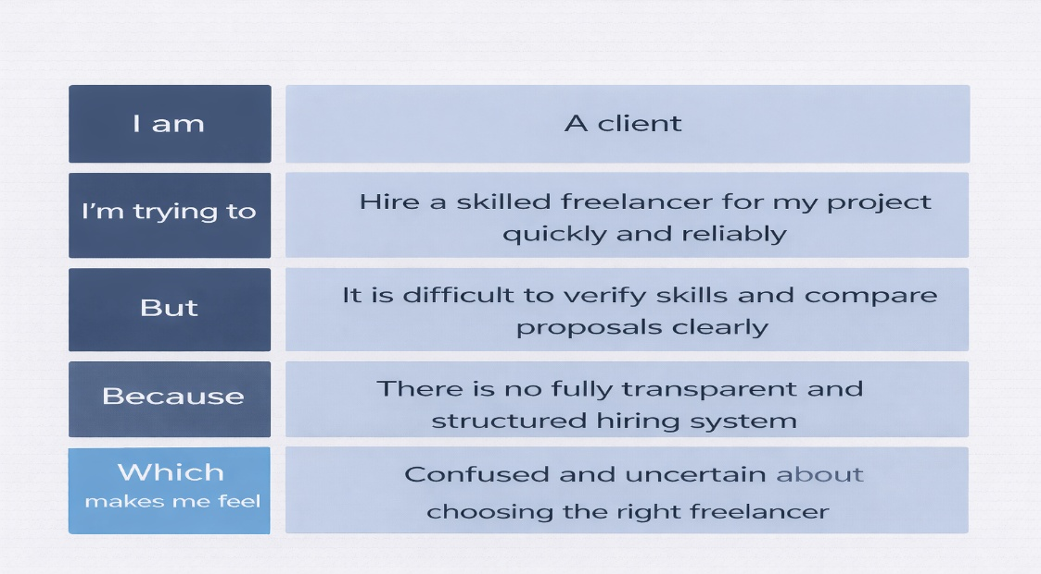

|  |  |  |  |  |  |
| --- | --- | --- | --- | --- | --- |
| **Problem Statement (PS)** | **I am** | **I’m trying to** | **But** | **Because** | **Which makes me feel** |
| PS-1 | A freelancer | Find genuine projects and manage my work efficiently | Project details are unclear and communication is scattered | There is no centralized and transparent collaboration system | Frustrated and uncertain |
| PS-2 | A client | Hire a skilled freelancer quickly and reliably | It is difficult to verify skills and compare proposals clearly | There is no fully transparent and structured hiring system | Confused and uncertain |

**2.2 Empathy Map:**

**User :** Durga Prasad Nekkanti (Working Professional Seeking Reliable Freelance Services for Business Projects)

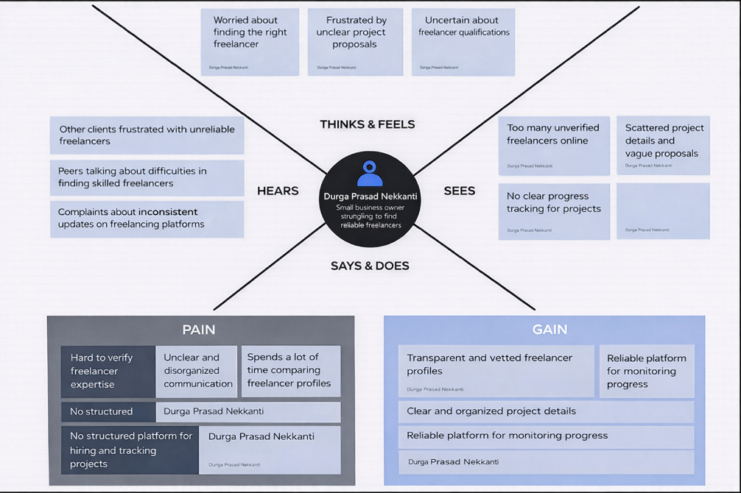

**2.2 Brainstorm & Idea Prioritization:-**

**Step-1: Team Gathering, Collaboration and Select the Problem Statement**

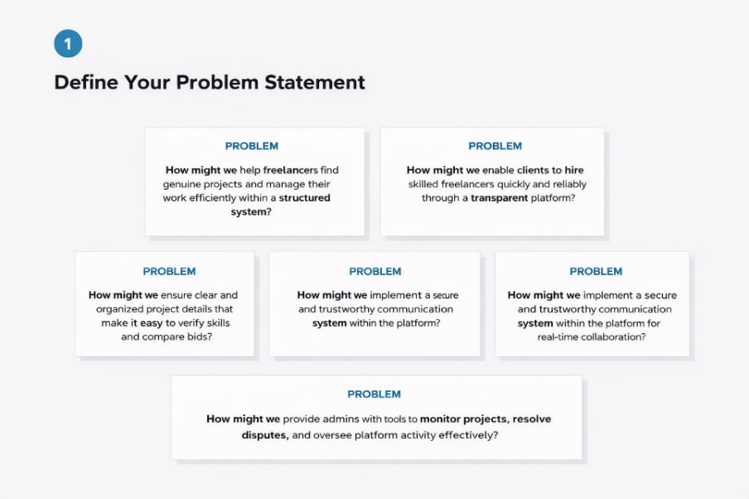

**Step-2: Brainstorm, Idea Listing and Grouping**

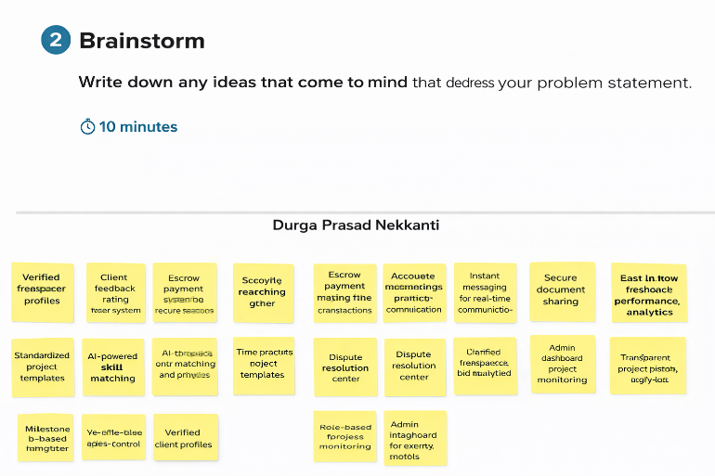

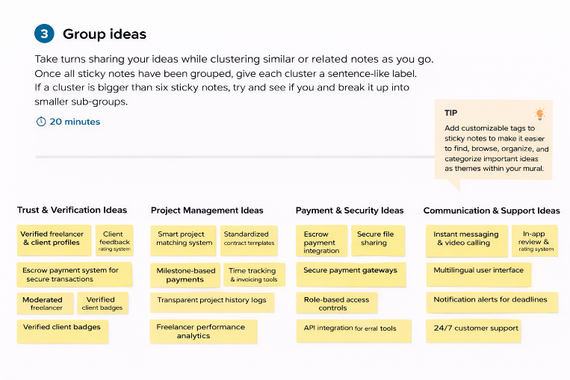

**Step-3: Idea Prioritization**

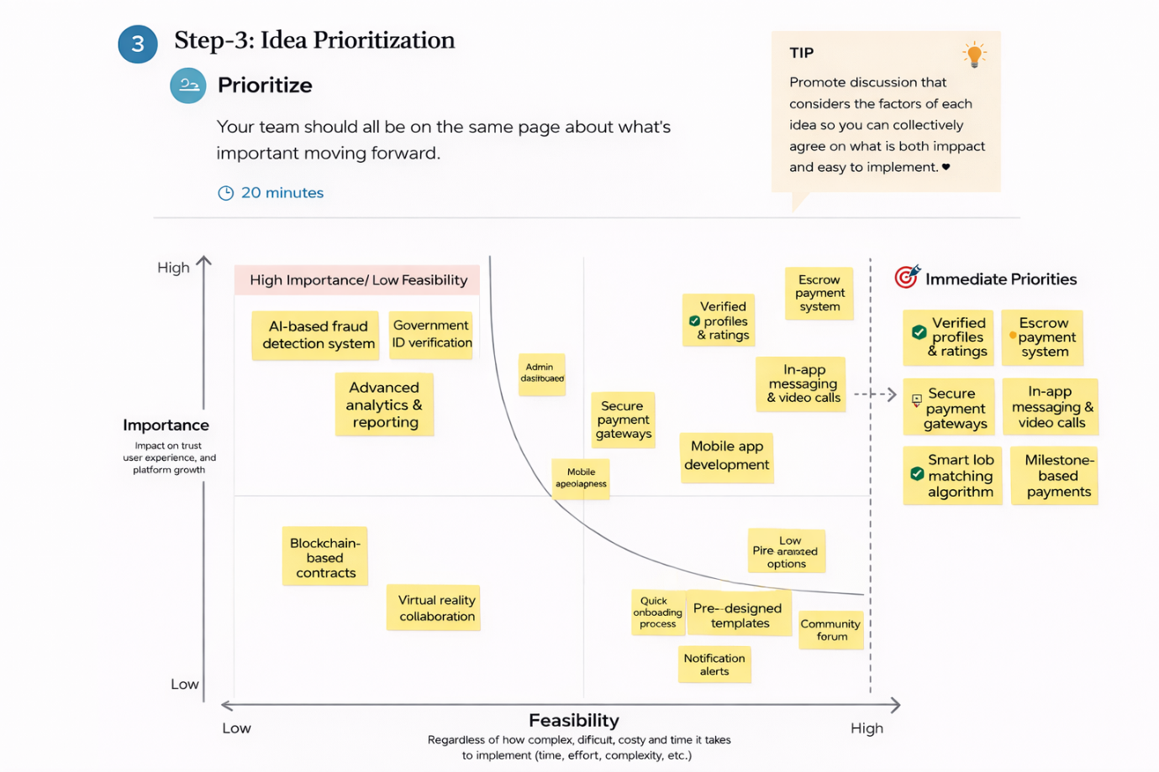

**3. REQUIREMENT ANALYSIS**

**3.1 Customer Journey map: -**

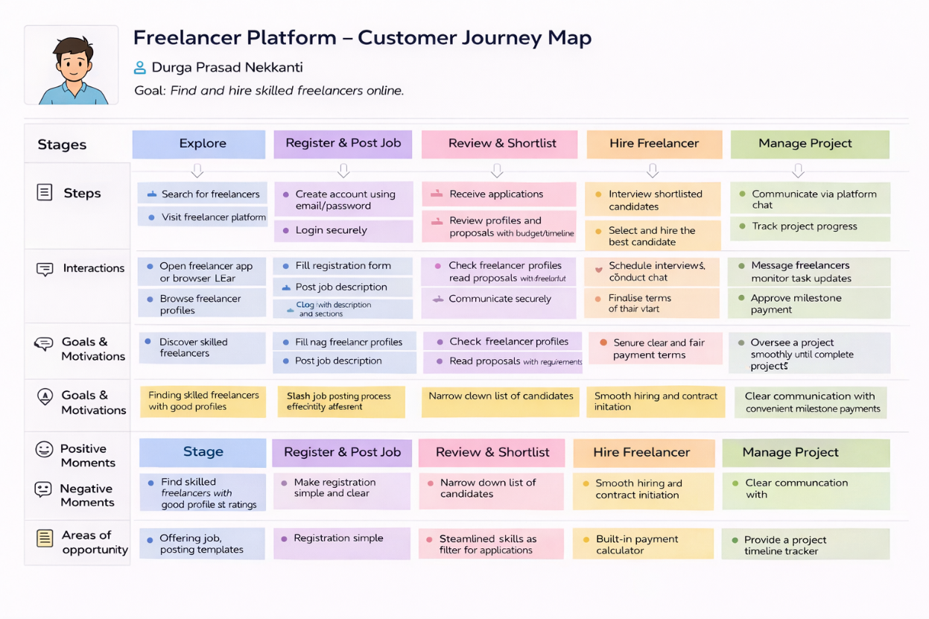

**3.2 Solution Requirement**

Following are the functional requirements of the proposed solution.

|  |  |  |
| --- | --- | --- |
| FR No. | Functional Requirement (Epic) | Sub Requirement (Story / Sub-Task) |
| FR-1 | User Registration | Registration through form Role selection (Client / Freelancer / Admin) Secure password creation |
| FR-2 | User Authentication | Login using Email & Password JWT-based authentication |
| FR-3 | Project Posting (Client) | Create project with title & description Set budget & deadline Attach documents |
| FR-4 | Freelancer Browsing & Search | View project listings on dashboard Filter by category / budget / skills |
| FR-5 | Bidding System | Submit proposal with quotation Attach portfolio samples Track bid status |
| FR-6 | Project Management | Client selects freelancer Milestone-based project tracking Update project status (Pending / Ongoing / Completed)Accept / Reject / Reschedule bookings |
| FR-7 | Communication System | In-platform chat between client & freelancer Real-time messaging & file sharing |
| FR-8 | Admin Governance | Approve user accounts if needed Monitor platform activity Handle disputes |

**Non-functional Requirements:**

Following are the non-functional requirements of the proposed solution.

|  |  |  |
| --- | --- | --- |
| **FR No.** | **Non-Functional Requirement** | **Description** |
| NFR-1 | **Usability** | Simple, intuitive interface allowing clients to post projects and freelancers to bid easily without technical complexity. |
| NFR-2 | **Security** | JWT authentication, encrypted passwords, secure payment gateway integration, and protected file uploads. |
| NFR-3 | **Reliability** | |  | | --- | |  |  |  |  |  |  | | --- | --- | --- | --- | | |  | | --- | |  |  |  | | --- | |  |  |  | | --- | | Accurate bid tracking, secure transaction handling, and consistent project status updates without data loss. | | |
| NFR-4 | **Performance** | Fast dashboard loading and smooth API communication between React frontend and Express backend. |
| NFR-5 | **Availability** | Platform accessible 24/7 for clients, freelancers, and admins. |
| NFR-6 | **Scalability** | MERN stack architecture allows expansion to support large numbers of users and projects. |

**3.3 Data Flow Diagram: -**

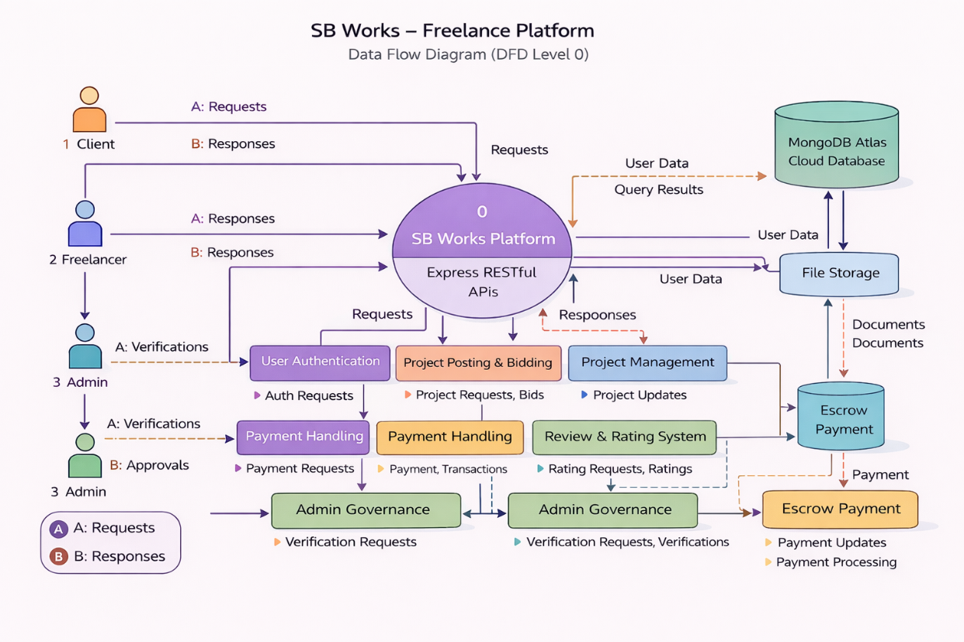

**User Stories**

| **User Type** | **Functional Requirement (Epic)** | **User Story Number** | **User Story / Task** | **Acceptance criteria** | **Priority** | **Release** |
| --- | --- | --- | --- | --- | --- | --- |
| Client (Web User) | Registration | USN-1 | |  | | --- | |  |   As a user, I can register using email and password | Account created & dashboard accessible | High | Sprint-1 |
| Client / Freelancer | Authentication | USN-2 | As a user, I can log in securely | Successful login redirects to dashboard | High | Sprint-1 |
| Client | Project Posting | USN-3 | As a client, I can post a new project with details | Project appears in project listing dashboard | High | Sprint-1 |
| Freelancer | Project Browsing | USN-4 | As a freelancer, I can view available projects | Project list loads from database | High | Sprint-2 |
| Freelancer | Bidding System | USN-5 | As a freelancer, I can submit a proposal for a project | Proposal saved and visible to client | High | Sprint-2 |
| Client | Freelancer Selection | USN-6 | As a client, I can select a freelancer from proposals | Selected freelancer status updated to “Assigned” | High | Sprint-3 |
| Freelancer | Project Management | USN-7 | As a freelancer, I can update project status | Status updates to Ongoing / Completed | High | Sprint-3 |
| Client | Review & Rating | USN-8 | As a client, I can rate a freelancer after completion | Rating saved and displayed on freelancer profile | Medium | Sprint-4 |
| Admin | User Monitoring | USN-9 | As an admin, I can monitor platform activity | Admin dashboard shows user and project data | Medium | Sprint-5 |

**3.4 Technology Stack: -**

The SB Works application is developed using modern full-stack technologies based on the MERN stack architecture.

1. **Frontend Technologies**

* React.js – For building dynamic and responsive user interfaces
* Bootstrap & Material UI – For designing attractive and responsive UI components
* Axios – For handling HTTP requests and communicating with backend APIs

1. **Backend Technologies**

* Node.js – Server-side runtime environment
* Express.js – Web framework for building RESTful APIs
* JWT (JSON Web Token) – For secure authentication and authorization
* Multer – For handling file uploads (project documents, attachments)

1. **Database**

* MongoDB – NoSQL database for storing user data, project details, bids, transactions, and reviews

**Table-1: Components & Technologies:**

|  |  |  |  |
| --- | --- | --- | --- |
| **S. No** | **Component** | **Description** | **Technology** |
|  | User Interface | Web interface for Clients, Freelancers, and Admin dashboards | React.js, HTML, CSS, Bootstrap, Material UI |
|  | Application Logic-1 | Authentication & Role Management (Client / Freelancer / Admin) | Node.js, Express.js, JWT |
|  | Application Logic-2 | Project Posting, Bidding & Management | Express.js REST APIs |
|  | Application Logic-3 | Notification, Review & Status Management | Node.js Controllers |
|  | Database | Stores users, projects, bids, reviews, and transactions | MongoDB, Mongoose |
|  | Cloud Database | Cloud-hosted NoSQL database for storing user profiles, project data, bids, and notifications with remote access and scalability | MongoDB Atlas |
|  | File Storage | Project document upload & attachment storage | Local Filesystem / Cloud Storage Service |
|  | External API-1 | |  | | --- | |  |  |  | | --- | | HTTP communication between frontend & backend | | Axios |
|  | External API-2 | Payment Gateway Integration (if implemented) | __ |
|  | Machine Learning Model | Not used in this project | __ |
|  | Infrastructure (Server / Cloud) | Local development deployment & backend hosting | Node.js Local Server |

**Table-2: Application Characteristics:**

| **S. No** | **Characteristics** | **Description** | **Technology** |
| --- | --- | --- | --- |
|  | Open-Source Frameworks | Frameworks used to build frontend UI and backend REST APIs | React.js, Express.js, Node.js |
|  | Security Implementations | Role-based authentication (Client / Freelancer / Admin), encrypted passwords, protected routes | JWT, bcryptjs, Middleware |
|  | Scalable Architecture | 3-Tier architecture separating frontend, backend logic, and database layer | REST Architecture, MongoDB |
|  | Availability | |  | | --- | |  |  |  | | --- | | Web application accessible anytime via browser for clients, freelancers, and admins | | Node.js Server |
|  | Performance | Fast API responses, asynchronous data handling, and smooth frontend-backend communication | Axios, Express.js |

**4. PROJECT DESIGN**

**4.1 Problem Solution Fit : -**

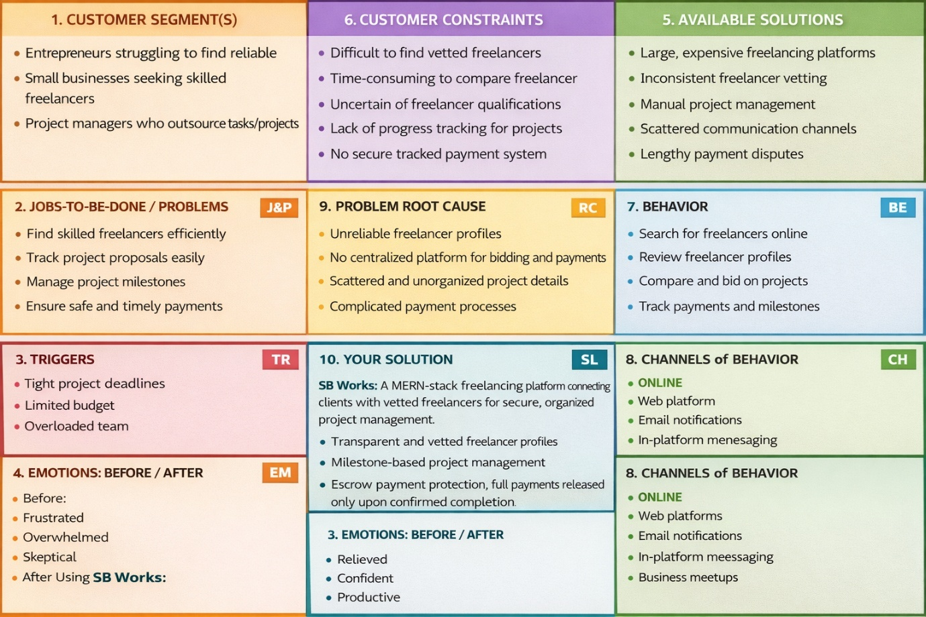

**4.2 Proposed Solution : -**

|  |  |  |
| --- | --- | --- |
| **S.No.** | **Parameter** | **Description** |
|  | Problem Statement (Problem to be solved) | Clients face difficulty finding reliable freelancers due to scattered communication, lack of transparency, and unverified profiles. Freelancers struggle to secure genuine projects and manage work efficiently. Admins require a centralized and secure system to monitor activities and maintain platform trust. |
|  | Idea / Solution description | **SB Works** is a MERN-stack web application that connects clients and freelancers through a centralized freelancing platform. It provides role-based dashboards (Client, Freelancer, Admin), project posting and bidding system, real-time communication, JWT-based secure authentication, document upload, project status tracking, and REST APIs integrated with MongoDB Atlas. |
|  | Novelty / Uniqueness | Role-based freelancing workflow, transparent bidding system, admin monitoring, milestone-based project tracking, secure document sharing, and a simplified user-friendly collaboration interface. |
|  | Social Impact / Customer Satisfaction | Encourages fair work opportunities, supports small businesses and independent professionals, ensures secure transactions, improves transparency, and enhances trust in the freelancing ecosystem. |
|  | Business Model (Revenue Model) | Commission-based transaction model, subscription plans for premium freelancers, featured project listings, and future integration of escrow-based secure payments. |
|  | Scalability of the Solution | Built using 3-tier MERN architecture (React frontend, Express backend, MongoDB Atlas cloud database), allowing scalable performance, secure data handling, and easy expansion to support more users and project categories. |

**4.3 Solution Architecture:**

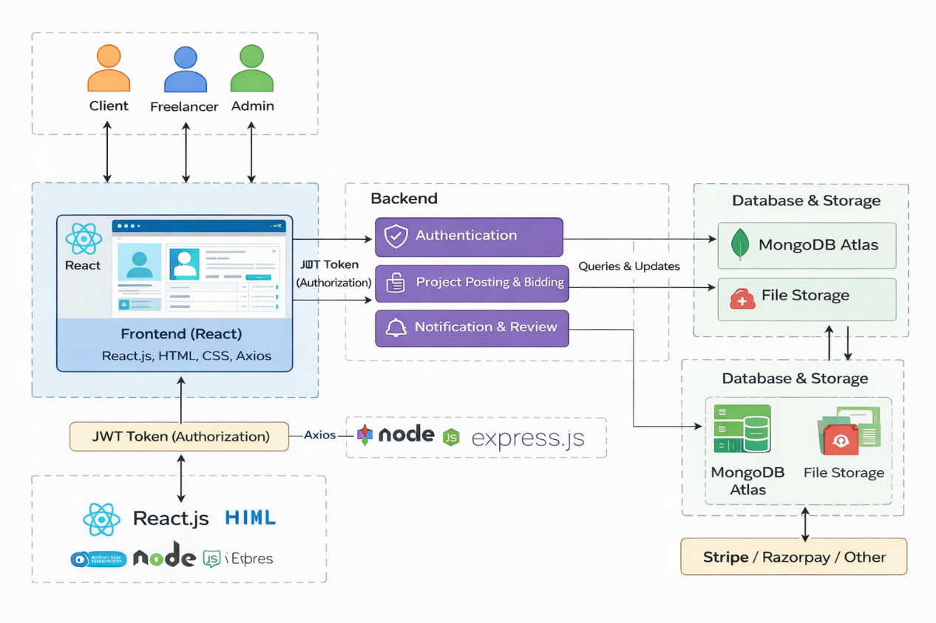

*Figure-1: Architecture and Data Flow of the SB Works Freelancing Platform*

**5. PROJECT PLANNING & SCHEDULING**

**5.1 Project Planning : -**

**Product Backlog, Sprint Schedule, and Estimation :**

| **Sprint** | **Functional Requirement (Epic)** | **User Story Number** | **User Story / Task** | **Story Points** | **Priority** | **Team Members** |
| --- | --- | --- | --- | --- | --- | --- |
| Sprint-1 | Registration | USN-1 | |  | | --- | |  |   As a user, I can register using email and password | 2 | High | Team |
| Sprint-1 | Authentication | USN-2 | As a user, I can log in securely using JWT authentication | 2 | High | Team |
| Sprint-1 | Dashboard | USN-3 | As a user, I can view projects (Client/Freelancer) on dashboard | 3 | High | Team |
| Sprint-2 | Project Posting | USN-4 | |  | | --- | |  |   As a client, I can post a project with title, description, budget & deadline | 5 | High | Team |
| Sprint-2 | Proposal Submission | USN-5 | As a freelancer, I can submit a proposal for a project | 3 | Medium | Team |
| Sprint-3 | Project Management | USN-6 | As a freelancer, I can update project status (Ongoing / Completed) | 5 | High | Team |
| Sprint-3 | Admin Panel | USN-7 | As an admin, I can monitor users and manage platform activities | 4 | High | Team |
| Sprint-4 | Notifications | USN-8 | As a user, I receive project status and proposal updates | 3 | Medium | Team |
| Sprint-4 | |  | | --- | |  |  |  | | --- | | Project History | | USN-9 | As a user, I can view and manage project history | 3 | Medium | Team |

**Project Tracker, Velocity & Burndown Chart:**

| **Sprint** | **Total Story Points** | **Duration** | **Sprint Start Date** | **Sprint End Date (Planned)** | **Story Points Completed (as on Planned End Date)** | **Sprint Release Date (Actual)** |
| --- | --- | --- | --- | --- | --- | --- |
| Sprint-1 | 15 | 4 Days | 01 Feb 2025 | 04 Feb 2025 | 15 | 04 Feb 2025 |
| Sprint-2 | 16 | 4 Days | 05 Feb 2025 | 08 Feb 2025 | 16 | 08 Feb 2025 |
| Sprint-3 | 14 | 4 Days | 09 Feb 2025 | 12 Feb 2025 | 14 | 12 Feb 2025 |
| Sprint-4 | 12 | 3 Days | 13 Feb 2025 | 15 Feb 2025 | 12 | 15 Feb 2025 |

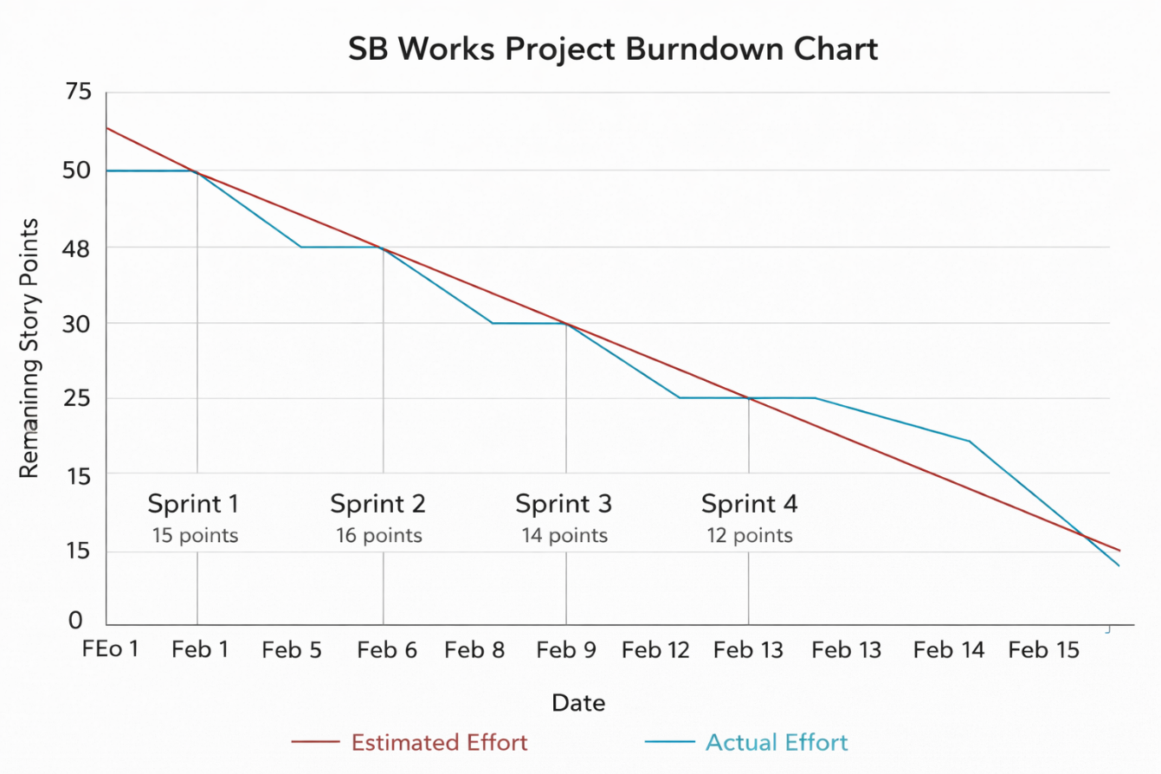

**6. FUNCTIONAL AND PERFORMANCE TESTING**

**6.1 Performance Testing**

**Test Scenarios & Results**

|  |  |  |  |  |  |
| --- | --- | --- | --- | --- | --- |
| **Test Case ID** | **Scenario (What to test)** | **Test Steps (How to test)** | **Expected Result** | **Actual Result** | **Pass/Fail** |
| FT-01 | User Registration | Enter valid & invalid user details | Valid registration succeeds; errors for invalid input | Registration works correctly | Pass |
| FT-02 | User Login | Enter correct & incorrect credentials | Login success for valid; error for invalid | Authentication works | Pass |
| FT-03 | Role-Based Access | Login as Client / Freelancer / Admin | User redirected to respective dashboard | Role-based dashboard loads correctly | Pass |
| FT-04 | Project Listing | Load project dashboard | Projects fetched from database | Projects displayed correctly | Pass |
| FT-05 | Project Posting (Client) | Create new project with details | Project stored in DB & visible to freelancers | Project added successfully | Pass |
| FT-06 | Proposal Submission (Freelancer) | Submit bid for a project | Proposal stored & visible to client | Proposal submitted successfully | Pass |
| FT-07 | Project Status Update | Update project status (Ongoing/Completed) | Status updated in DB & reflected in UI | Status updated correctly | Pass |
| FT-08 | Review & Rating | Submit rating after project completion | Rating saved & displayed on profile | Rating recorded successfully | Pass |
| FT-09 | Notification System | Trigger project update event | User receives notification in dashboard | Notification displayed correctly | Pass |
| FT-10 | |  | | --- | |  |  |  | | --- | | File Upload | | Upload project document/attachment | File stored & accessible | File uploaded successfully | Pass |

**Performance Testing**

|  |  |  |  |  |  |
| --- | --- | --- | --- | --- | --- |
| **Test Case ID** | **Scenario** | **Test Steps** | **Expected Result** | **Actual Result** | **Pass/Fail** |
| PT-01 | Page Load Time | Load homepage/products | < 2 seconds | ~1.5 sec | Pass |
| PT-02 | API Response | Fetch products API | Fast response | Stable | Pass |
| PT-03 | Concurrent Users | Multiple users post projects / submit bids simultaneously | No crash | Stable | Pass |
| PT-04 | DB Query Speed | Search/filter projects | Quick retrieval | Fast | Pass |
| PT-05 | Order Processing Load | Multiple payment simulations (if integrated) | Transactions stored correctly without failure | Stable | Pass |

**7. RESULTS**

**7.1 Output Screenshots**

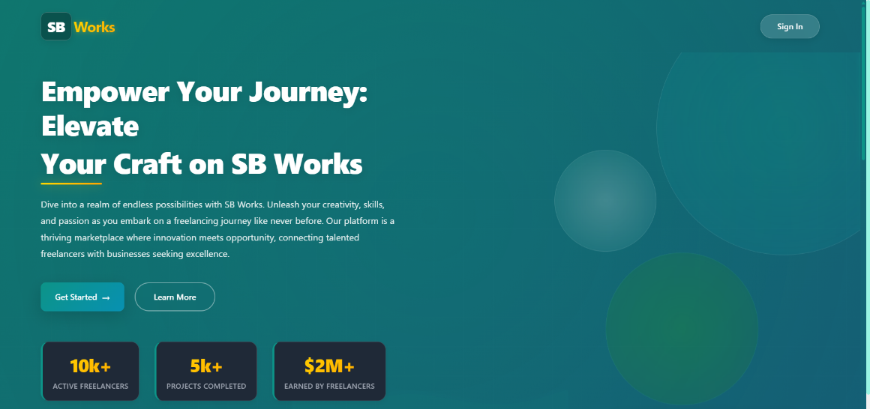

**Fig 1 : Sbworks Home Page**

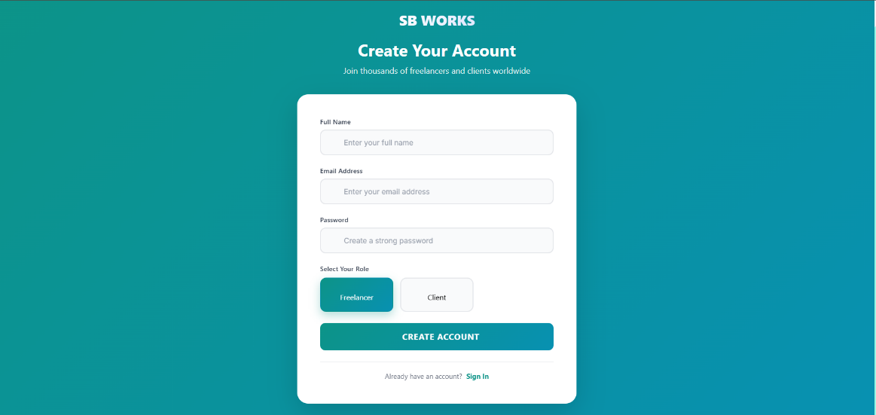

**Fig 2 : Registration Page**

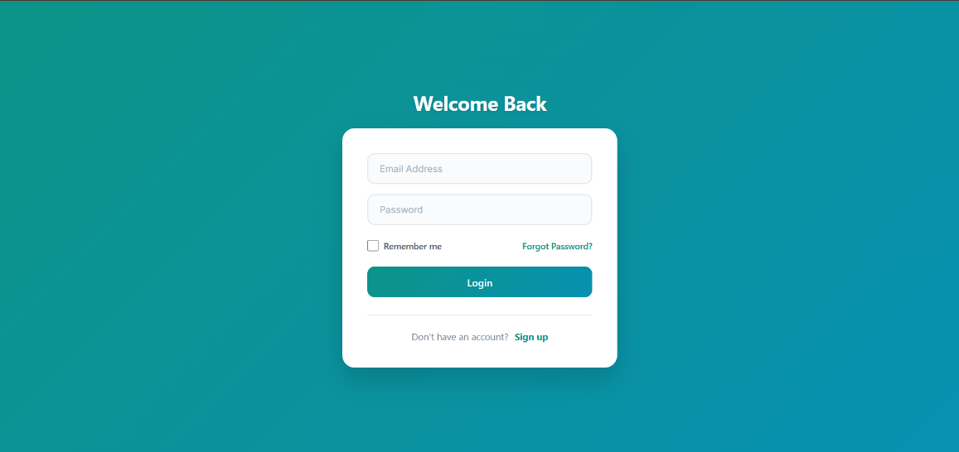

**Fig 3 : Login Page**

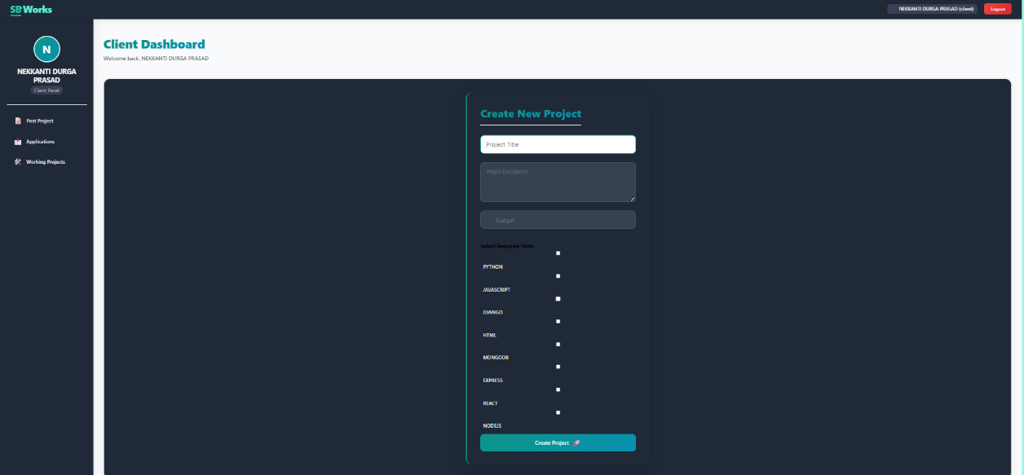

**Fig 4 : Client Dashboard**

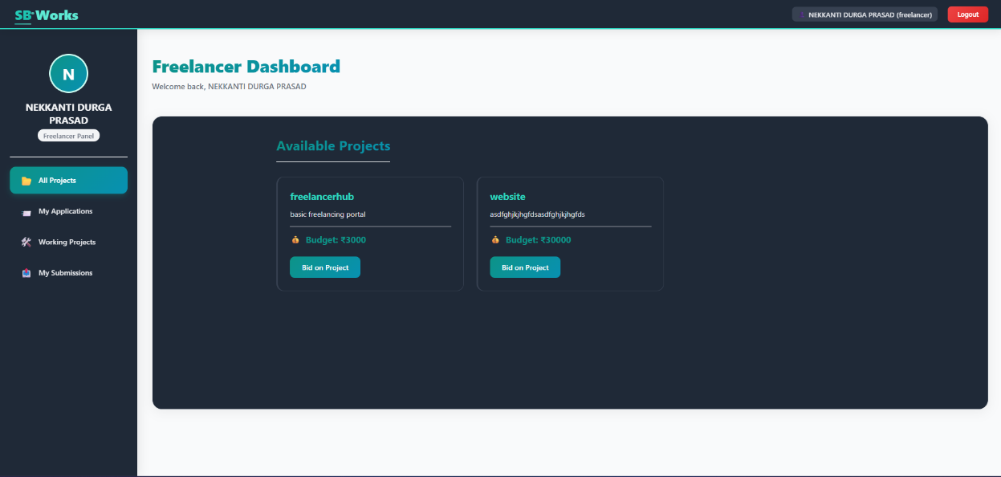

**Fig 5 : Freelancer Dashboard**

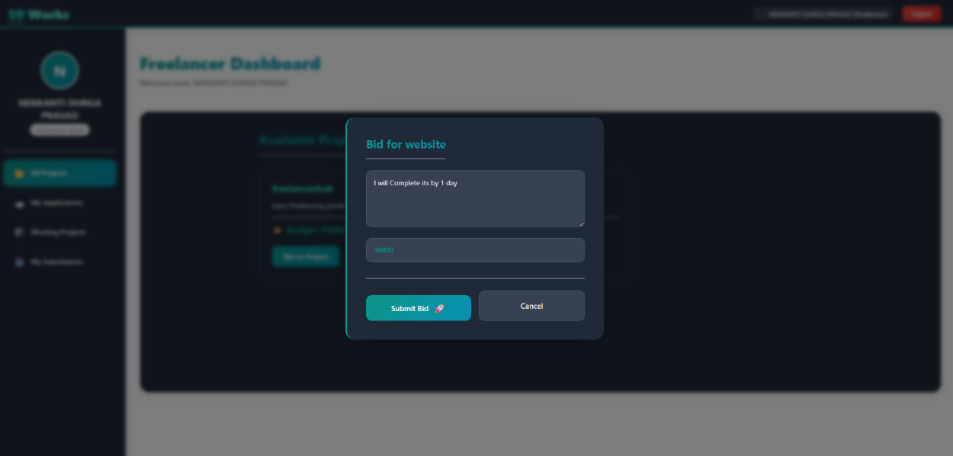

**Fig 6 : Project Bidding Page**

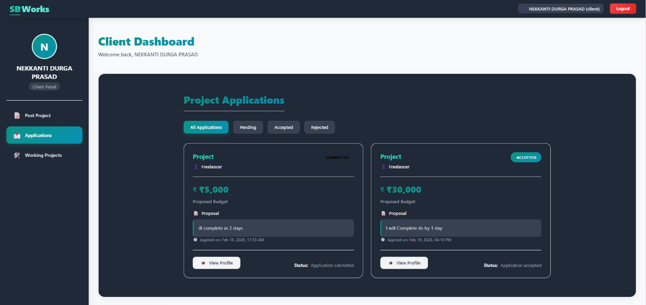

**Fig 7 : Bidding Approval Page**

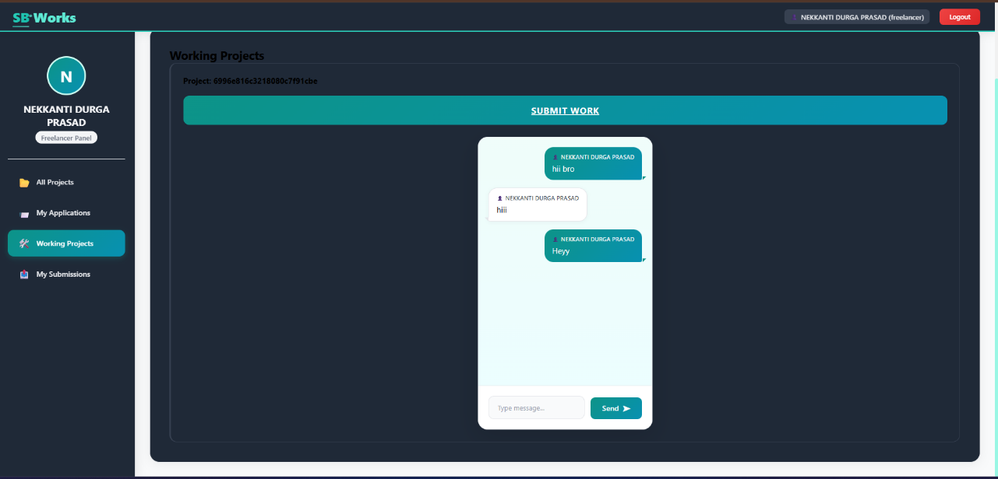

**Fig 8 : Chating page**

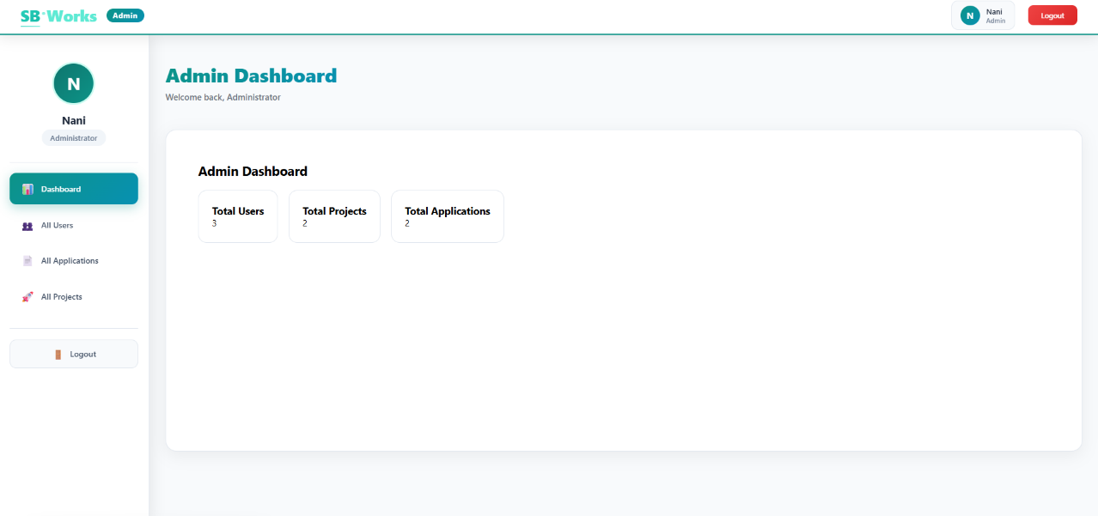

**Fig 9 : Admin Dashboard**

**8. ADVANTAGES & DISADVANTAGES**

**Advantages of the SB Works Project**

**1. Full-Stack MERN Implementation**

The project demonstrates complete frontend and backend integration using the MERN stack (MongoDB, Express.js, React.js, Node.js), providing real-world full-stack development experience.

**2. Role-Based Access Control**

Separate roles for Client, Freelancer, and Admin ensure secure access control and proper authorization for project posting, bidding, and platform management.

**3. Scalable Architecture**

The modular structure and RESTful API design make the application easy to maintain, extend, and scale for future enhancements.

**4. Secure Authentication**

JWT-based authentication ensures secure and stateless communication between frontend and backend.

**5. Structured Freelancing Workflow**

Features such as project posting, proposal submission, project status tracking, and review & rating system provide a smooth collaboration experience.

**6. Admin Governance System**

The admin dashboard enables monitoring of users, projects, and platform activities to maintain trust and security.

**7. Academic and Practical Learning Value**

The project covers authentication, API development, database schema design, role-based authorization, and frontend routing, making it a strong academic and industry-relevant project.

**Disadvantages of the SB Works Project**

**1. Limited Payment Gateway Integration**

If real escrow/payment gateway is not fully implemented, it limits production-level deployment.

**2. Basic UI/UX Design**

The interface focuses primarily on functionality rather than advanced professional UI/UX design standards.

**3. Token Storage in Local Storage**

JWT stored in local storage may present security risks in large-scale applications.

**4. Limited Performance Optimization**

No advanced optimization techniques such as caching, load balancing, or microservices architecture are implemented.

**5. Limited Real-Time Features**

Notifications and project updates may not be fully real-time (no WebSocket integration).

**6. No Automated Testing Framework**

The system primarily relies on manual testing rather than automated unit and integration testing tools.

**7. Limited DevOps & Deployment Configuration**

Advanced deployment strategies such as CI/CD pipelines, Docker containerization, and cloud scaling are not implemented.

**9. CONCLUSION**

The **SB Works** project successfully demonstrates the design and implementation of a full-stack freelancing web application using the MERN stack (MongoDB, Express.js, React.js, and Node.js). The system was developed with the objective of creating a secure, transparent, and structured platform that connects clients and freelancers efficiently while maintaining proper role-based access control.

Throughout the development process, emphasis was placed on clean architecture, modular coding practices, and efficient database design to ensure scalability, maintainability, and performance. The platform enables users to register, log in securely, post projects, submit proposals, manage project workflows, and provide reviews and ratings in a streamlined manner. On the administrative side, the dashboard provides centralized monitoring of users, projects, and system activities to maintain platform integrity.

JWT-based authentication ensures secure communication between the frontend and backend, while middleware-based authorization enforces role-based access restrictions. The integration between React frontend and Express backend through RESTful APIs demonstrates effective client-server communication. Proper validation, error handling, and structured project organization enhance system reliability and usability.

Although advanced features such as real-time notifications, full escrow-based payment integration, cloud deployment, and automated testing frameworks can be implemented in future versions, the current system effectively meets the core requirements of a freelancing platform.

In conclusion, **SB Works** stands as a scalable and well-structured freelancing solution that reflects a strong understanding of modern full-stack development principles. With further enhancements, the platform has the potential to evolve into a fully production-ready and commercially viable freelancing ecosystem.

**10. FUTURE SCOPE**

The SB Works platform has a strong foundational architecture and can be further enhanced with advanced features and improvements to make it production-ready and commercially scalable. The following are potential future developments:

**1. Secure Payment & Escrow Integration**

The system can be integrated with secure online payment gateways such as UPI, credit/debit cards, and digital wallets. Implementing an escrow-based payment system will ensure secure milestone payments between clients and freelancers, increasing trust and reliability.

**2. Advanced User Interface and Experience**

Future improvements can focus on enhancing UI/UX using modern design systems and responsive layouts. Features such as interactive dashboards, animations, dark/light themes, enhanced profile pages, and improved project browsing filters can significantly improve user engagement.

**3. Real-Time Communication & Notifications**

Implementing real-time notifications using technologies like WebSockets or Socket.io will allow users to receive instant updates about:

* New proposals
* Project status changes
* Payment confirmations
* Admin announcements

**4. AI-Based Freelancer Recommendation**

Machine learning algorithms can be integrated to recommend suitable freelancers based on:

* Skill matching
* Past performance
* Ratings
* Project requirements

This would enhance hiring efficiency and platform intelligence.

**5. Enhanced Security Measures**

Security can be strengthened by:

* Storing JWT tokens in HTTP-only cookies
* Implementing refresh tokens
* Adding multi-factor authentication (MFA)
* Applying rate limiting and advanced validation
* Implementing fraud detection mechanisms

**6. Mobile Application Development**

A dedicated mobile application using technologies like React Native or Flutter can expand the platform to Android and iOS users, increasing accessibility and user engagement**.**

**11. APPENDIX**

My Project Source code Files are available at :

<https://drive.google.com/drive/folders/1SnRDtdutRNMhwjNX7WkuEJye0rVkL8P3?usp=sharing>

My project Demo Video link is available at :

https://drive.google.com/file/d/15VNxpXmzW4HsSYiBJqAcp6atDuzQD0PS/view?usp=sharing

Github Resopitory Link :

https://github.com/Durgaprasad3002/Freelance-Finder-Discovering-Opportunities-Unlocking-Potential-